Name _________________
MAT 201 Midterm (Online Class)
Please work out all of the given problems. Credit with be based on the work that is shown that contributes towards the final answer. If you are using the calculator to solve a problem, be sure to write down what you are putting in your calculator. Also show all normal and Student T diagrams.

Problem 1 (20 Points) (For each part be sure to write down the sampling distribution for each, put in your normal curve diagram, answer the question and determine whether the normality assumption was needed.) The average size of small family farms is 231 acres. Suppose that the distribution of small family farm sizes is normally distributed and the standard deviation is 40 acres.
- Find the third quartile for small family farm size.
  - Distribution: X ~N(231,40)
  - Diagram: 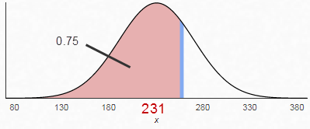
  - Answer: invNorm(.75,231,40) = 257.98
  - Assumption Validity (Explain) Since this is just for a single farm, the normality assumption is needed.

- If 53 small family farms are evaluated, find the probability that their average size will be larger than 235 acres.
  - Distribution: $X\sim N(231,\frac{40}{\sqrt{53}})$
  - Diagram: 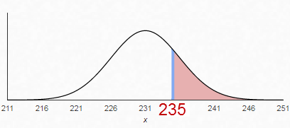
  - Answer: normalcdf(235,999999,$\frac{40}{\sqrt{53}})$ = 0.2333
  - Assumption Validity (Explain): Since n = 53 > 30, the normality assumption is not needed.
Problem 2 (20 Points)
A restaurant owner wanted to see if paying for a person to stand outside by the street waving a colorful advertisement banner would add more customers. Suppose that without this advertisement, the restaurant averages 25 customers per evening.

- Discuss the implications of a Type I Error.
We conclude that the add person is effective when the person is not. You pay this person money when it does not help increase the number of customers at the restaurant. Profit goes down since costs are higher but revenue is not increased.

- Discuss the implications of a Type II Error.
There is no evidence to say that the add person is effective, but it is effective in increasing the number of customers at the restaurant. The add person loses his/her job and the owner misses out in an opportunity to increase the number of customers.

- Suppose that on the 35 nights that the human street ad was tried out, the restaurant averaged 29 customers per evening with a standard deviation of 12 customers. Test the hypothesis and state your conclusion in the context of the study. Be sure to state the null and alternative hypothesis, the p-value, and the test you are using in your calculator. Then state your conclusion using a complete sentence in the context of the study.
$H_{0}: μ=25$, $H_{1}: μ>25$ t-test, p = 0.02839

There is statistically significant evidence to conclude that the population mean number of customers with the human street ad is greater than 25 per night.

Problem 3 (3 Points Each) Please circle the following True or False.
A. The expected value for the number of hours that college students study per week
is 8.4 hours. Then if thousands of college students were randomly selected, it would be very unlikely for the average number of hours that these students studied to be less than 8 hours. True False

B. If you wanted to see if men are more likely than women to go backpacking this
year and you will be using stratified sampling, then you will want to make sure
the percent of men in your study is the same as the percent of men in the
population. True False

C. If x is a random variable that follows a uniform distribution on [7,18], then
P(x = 5) = P(x = 9). True False

D. If you have a sample of size 50 and you want to decrease the standard error by a
factor of 3, then you will need to sample a total of 150 people instead.
True False

E. If you want to determine if the distribution of your population is unimodal or
bimodal, then it is better to look at a histogram than a box plot.
True False

F. A researcher surveyed 35 randomly selected Americans to construct a confidence
interval for the proportion of all Americans who have a PhD. Since the sample
size is larger than 30, the Central Limit Theorem can be used to conclude that the
sampling distribution is normal. True False

G. If A and B are events such that P(A) = 0.2 and P(B) = 0.7, then
P(A and B) = 0.14. True False

H. For a normal distribution, the mean median and mode are all equal.
True False

Problem 4 (20 Points) Suppose that the time it takes for a nurse to administer a drug using a needle is uniformly distributed between 2 and 6 seconds.

- What is the probability that a randomly observed drug injection will take between 2.4 and 4.1 seconds? Be sure to include your diagram.

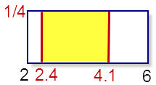
First get the height using A = 1 = bh = (6 - 2)h = 4h, thus h = ¼.

Next find P(2.4 < x < 4.1) = bh = (4.1 – 2.4)*1/4 = 0.425

- If 8 randomly selected drug injections are observed what is the probability that at least 3 of them will take longer than 3.5 seconds?
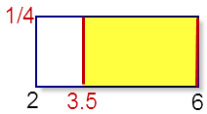

First find the probability that a single injection will take longer than 3.5 seconds:
P(3.5 < x) = bh = (6 – 3.5)*1/4 = 0.625
Now use: 1 – binomialcdf(8,0.625,2) = 0.9640

- Find the 20th percentile for the time it takes to inject a drug.
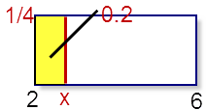
Use 0.2 = A = bh = (x -2)*1.4
0.2*4 = x -2
0.8 = x – 2
x = 2.8

Problem 5 (10 Points) Suppose that the mean amount of time it takes for Olympic snowboarders to go down a run is 37 seconds with a standard deviation of 2 seconds. The mean amount of time it takes a beginner to go down a run is 289 seconds with a standard deviation of 83 seconds. You observe an Olympic snowboarder go down a run in 34 seconds and a beginner go down a run in 121 seconds. Use z-scores to determine whose time was more unusually fast considering the person’s experience.

Olympic: $μ=37, σ=2, x=34: z= \frac{34-37}{2}= -1.5$

Beginner: : $μ=121, σ=83, x=289: z= \frac{121-289}{83}= -2.024$

Since the z-score for the beginner is farther from 0 and negative, we can conclude that the beginner’s time was more unusually fast compared considering the person’s experience.

Problem 6 (20 Points) How many units does the average online college student take per year? Ten online students were surveyed and the results are shown below.

Units | 24 | 38 | 9 | 22 | 30 | 45 | 42 | 18 | 36 | 32

- Determine the appropriate 95% confidence interval.

Use T-Interval with Data to get [21.4912,37.7088]

- Write a sentence that explains your findings.
With 95% confidence, it can be concluded that the population mean number of units the average online college student takes per year is between 21.5 and 37.7 units.

- Use a sentence or two to explain what it means in the context of this study to be 95% confident.
If many groups of 10 students are surveyed, each group would produce its own confidence interval. 95% of these will contain the true population mean number of units online college students take.

- Was it necessary to make any assumptions about the underlying distribution of the population? Explain.
Yes, n = 10 < 31, so we must assume the population distribution is normal.

Problem 7 (20 Points) A researcher wanted to estimate the proportion of Americans who struggle with hunger due to finances.
- If the researcher wants to construct a 86% confidence interval with a margin of error of plus or minus 2%, at least how many Americans must be surveyed?
Use the formula: $n=0.25{\left(\frac{z}{E}\right)}^{2}$. E = 0.02. To find z note that 0.86 is inside the confidence interval, so 0.14 is outside, so 0.07 is to the left.
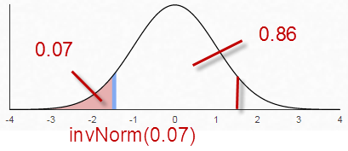
Compute: $n=0.25{\left(\frac{-1.4758}{0.02}\right)}^{2}=1365.24$
Thus you need to survey at least 1366 Americans.
- Suppose instead, the researcher surveyed 500 people and 63 of them struggle with hunger due to finances. Determine the appropriate 95% confidence interval.
Use 1PropZInt to get [0.0969,0.1551]
- Write a sentence to present your conclusion from part B.
With 95% confidence, it can be concluded that between 9.7% and 15.5% of all Americans struggle with hunger due to finances.

Problem 8 (20 Points) In November, Gallup found that 51% of all Americans support new gun control legislation. You think that the number has changed since the Florida shooting. You survey 900 Americans and found that 482 support new gun control legislation.
- Write down the appropriate null and alternative hypotheses and find the test statistic and the P-Value for this study.
$$H_{0}: p=0.51, H_{1}: p ≠0.51$$Use the 1PropZTest to get
z = 1.5336 as the test statistic and p-value = 0.1251.
- Use a complete sentence to state the results in the context of the survey using a level of significance of 0.05.
There is statistically insignificant evidence to make a conclusion whether or not the percent of all Americans who support new gun control legislation has changed from 51% since the Florida shooting.
- The P-Value represents a probability. Write a few sentences that interpret this probability in the context of the study.
If 51% of all Americans support new gun legislation and if another group of 900 Americans were surveyed, there would be a 12.5% chance that either at least 482 of them would support new gun legislation or fewer than 334 of them would support new gun legislation.
- The level of significance represents a probability. Write a few sentences that interpret this probability in the context of the study.
If 51% of all Americans support new gun legislation and if another group of 900 Americans were surveyed, there would be a 5% chance that the conclusion would be that the percent of Americans who support new gun legislation would be different from 51%.

Problem 9 (20 Points) The relative frequency histogram below shows the age distribution of customers at a local ski resort.

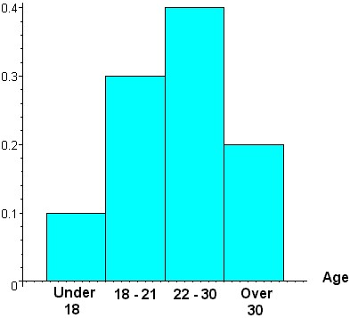
- What is the probability that a customer selected at random will be younger than 22?
0.4

- What is the probability that a customer selected at random will be over 21 given that that customer is 30 years old or younger?
$$P\left(x>21 | x<30\right)=\frac{P(21<x ≤30)}{P(x≤30)}=\frac{0.4}{0.8}=0.5$$

- If a one year old baby skier was added to the population of customers, would the standard deviation go up, down, or stay the same? Explain.

If a one year old is added, this would be an outlier and outliers make the standard deviation go up.

